Cowin-Vaccine Availability Checker

A project report submitted in the partial fulfillment of the requirements for the

Award of the degree of

BACHELOR OF TECHNOLOGY

In

ELECTRONICS AND COMMUNICATION ENGINEERING

Submitted By

Abhiram Kattunga

Reg.no: 122010404036

Under the Guidance of Mr. Pavan Chitneedi



18 July 2021

DECLARATION BY THE CANDIDATE

I the undersigned solemnly declare that the project report **COWIN-VACCINE AVAILABILITY CHECKER** is based on my own work carried out during the course of our study under the supervision of **Pavan Chitneedi**. I assert the statements made and conclusions drawn are an outcome of my research work. I further certify that

1. The work contained in the report is original and has been done by me under the general supervision of my supervisor.
2. The work has not been submitted to any other institution for any other degree/diploma/certificate in this university or any other University of India or abroad.
3. We have followed the guidelines provided by the university in writing the report.
4. Whenever we have used materials (data, theoretical analysis, and text) from other sources, we have given due credit to them in the text of the report and giving their details in the references.

Abhiram Kattunga

(122010404036)

(PG-2122-ETSD-122)

ACCEPTANCE/OFFER LETTER

Date: 19-06-2021

Abhiram Kattunga

GITAM University, Visakhapatnam

Phoenix ID: PG-2122-ETSD-122

Dear Abhiram Kattunga,

We are pleased to extend an invitation for you to join the Phoenix Global Team!

Phoenix Global is a skill-development company that helps students acquire and master professional and soft skills as per the requirements of the industry benchmarked to world’s top firms, trained by top class industry professionals. Phoenix Global is a platform having Industry professionals with esteemed alma mater including the IITs and IIMs to mentor and train students on cutting-edge skills, critical to the emerging industries while also giving them an opportunity to intern on a project under the mentorship of industry professionals from the IITs /IIMs.

Our vision is to be a national leader in skill development and industry readiness training by providing differentiated training from top-class industry experts. The mission is to be a go-to skill development platform for students, imparting skills benchmarked at global standards that help them realize their dream careers profitably

Our core values, the 4Ps – Professionalism, Punctuality, Passion, Perseverance stand for who and what we are as an organization. We are pleased to formalize your relationship with Phoenix Global as a Summer Internship Trainee, details of which are as follows:

General information

Role : Trainee Engineer

Location : Remote (Virtual-WFH)

Period of internship : 1 Months

Date of Joining : 19-06-2021

End Date : 18-07-2021

1. Appointment: Your date of appointment is effective from the date of joining, which shall be 19 June 2021

2. Benefits:

1. You shall receive a Certificate of Internship Completion, Letter of Recommendation, a verified Internship report and Guide’s Evaluation Record. In addition, you are also entitled to benefits based on your performance that would be communicated to you post internship.
2. You will be entitled to leave, holidays, benefits, and other allowances as applicable to your category of employees and location of posting, in accordance with the rules of the Company. As an Intern, you are entitled to 2(two) leaves per months allotted on pro-rata basis (these do not include public holidays).

3. Code of Conduct:

1. The Company may require you, at any time, to perform any other administrative, managerial, supervisory, technical or other functions and you will be bound to carry out such functions.
2. You shall maintain proper discipline and dignity of your office/location and so shall deal with all matters.
3. You shall maintain and keep in your safe custody such as Measuring instruments, Safety Equipment and other assets that may be issued to you or may come in your possession and shall return the same when required in good condition.
4. You shall inform the Company of any changes in your personal data within 3 days of the occurrence of such change.
5. Any notice required to be given to you shall be deemed to have been duly and properly given if delivered to you personally or sent by post to you at your address, as recorded in the Company.
6. You shall be solely responsible for any issues that may arise between you and your previous employer with regard to your previous employment and the Company /any of its personnel are not responsible for the same.
7. You shall not apply for any other job outside without the prior written permission from the Management. In response to this communication of appointment you are required to confirm your acceptance by signing the duplicate copy of this order.

If it is found at any time that the information given by you is not correct/true/complete, this appointment may be withdrawn or may be terminated at any time after you have taken up employment with us. Please note that you are governed by all Rules and Regulations of the Company, which are in force from time to time, and the Company shall have the right from time to time to vary or modify any of the terms and conditions of service, which shall be binding on you.

We take pleasure in welcoming you to our organization and look forward to a mutually beneficial association.

We wish you all the best in your career.

Sincerely.

C:\Users\subhashk\Downloads\WhatsApp Image 2021-06-21 at 2.54.26 PM.jpeg

Harsha Y

Human Capital Management

In the name and seal of

PHOENIX GLOBAL

UAN: TS02D0052027

National Industrial Classification: 74 - Scientific and Technical Activities | 85 - Education

Registered Under Telangana State MSME-Category D

Website: www.phnxglobal.com

E-Mail: info@phnxglobal.com

Signed and Accepted



Employee Name: Abhiram Kattunga

Date: 19-06-2021

CERTIFICATE

This is to certify that this project work entitled

“**COWIN-VACCINE AVAILABILITY CHECKER**”

is the bonafide work carried out by Abhiram Kattunga, Reg. No: 122010404036 submitted in Partial fulfillment of the requirement for the Award of Degree of Bachelor of Technology in Electronics and Communication Engineering, during June-July 2021.

The results submitted in this project have been verified and are found to be satisfactory. The results embodied in this thesis have not been submitted to any other university for the award of the any other degree/diploma.



Pavan Chitneedi

Signature of project supervisor

ACKNOWLEDGEMENT

The satisfaction and euphoria that accompany the successful completion of any task would be incomplete without the mention of people who made it possible, whose constant guidance and encouragement crowned the efforts with success. It is a pleasant aspect that I have now the opportunity to express my gratitude for all of them.

The first person I would like to thank my project guide Mr. Pavan Chitneedi, who had given continuous critical suggestions and extension of proper working atmosphere, abiding interest has finally evolved into this research work.

It is indeed with a great sense of pleasure and immense sense of guidance that I acknowledge the help and I am highly indebted to Prof. M Venkateswara Rao, Vice Principal, and Gitam Institute Of Technology, for his support during the tenure of the internship.

I would like to express my sincere thanks to Prof. Beatrice Seventline J, Head of the Department of Electronics and communication engineering for providing the opportunity to Undertake this internship and encouragement in the completion of the project.

I am also thankful to all the staff members of the Electronics and communication Engineering Department for their valuable suggestions. I would like to thank my team mates and parents who extended their help, encouragement and moral support either directly or indirectly in this project.

Abhiram Kattunga

(122010404036)

CONTENTS

|  |  |  |
| --- | --- | --- |
| Chapter | Title of the Chapter / Chapter Name | Page No.s |
| A | ABSTRACT | 1 |
| I | Chapter 1 Python Programming | 2-3 |
| II | Chapter 2 APIs | 4-5 |
| III | Chapter 3 JSON Objects | 6-7 |
| IV | Chapter 4 About Project | 8-9 |
| V | Chapter 5 Code Snippets and Outputs | 10-11 |
| B | References and Appendix | 12 |

ABSTRACT

Vaccination is now open for people of age above 18. But getting a vaccination appointment is as difficult as findinganeedle in a haystack because slots are filled in an eye-blink. So, searching through the Co-WIN portal manually is slow and sometimes irritating as well because you will almost all the time land with a page showing all slots booked as there is a huge crowd of people who want to get vaccinated as early as possible.

So, this problem can be solved by making it easier for people to find out when the next appointment is available in their region. We will be using Co-WIN API which is made public by the government to fetch the data of the vaccines available in the country.

Firstly, we will be scrapping data from the API and coding it in a way to check the availability of covid vaccines in a particular city or a region. Secondly, we will be using some libraries and modules and making the code check whether it will be requiring these modules and libraries or not. Then we will be able to fetch data and print the desired output the users want. Also adding a sound to the code to make it easier to understand for the user.

ABOUT

Phoenix Global is a skill-development company that helps students acquire and master professional and soft skills as per the requirements of the industry benchmarked to world’s top firms, trained by top class industry professionals.

Phoenix Global is a platform having Industry professionals with esteemed alma mater including the IITs and IIMs to mentor and train students on cutting-edge skills, critical to the emerging industries while also giving them an opportunity to intern on a project under the mentorship of industry professionals from the IITs /IIMs.

Our vision is to be a national leader in skill development and industry readiness training by providing differentiated training from top-class industry experts. The mission is to be a go-to skill development platform for students, imparting skills benchmarked at global standards that help them realize their dream careers profitably

Our core values, the 4Ps – Professionalism, Punctuality, Passion, Perseverance stand for who and what we are as an organization.

SCHEDULE OF INTERNSHIP

|  |  |  |
| --- | --- | --- |
| **Day** | **Week** | **Activity Plan** |
| 1 | Saturday | Induction Program |
| 2 | Sunday | Pre-Readings/Material Distribution |
| 3 | Monday | Training Session - 1 |
| 4 | Tuesday | Training Session - 2 |
| 5 | Wednesday | Training Session - 3 |
| 6 | Thursday | Training Session - 4 |
| 7 | Friday | Training Session - 5 |
| 8 | Saturday | Teams formation for Project |
| 9 | Sunday | Weekend Off |
| 10 | Monday | Training Session - 6 |
| 11 | Tuesday | Training Session - 7 |
| 12 | Wednesday | Training Session - 8 |
| 13 | Thursday | Training Session - 9 |
| 14 | Friday | Training Session - 10 |
| 15 | Saturday | Project Title Allocation |
| 16 | Sunday | Weekend Off |
| 17 | Monday | Project Session - 1 |
| 18 | Tuesday | Project Session - 2 |
| 19 | Wednesday | Project Session - 3 |
| 20 | Thursday | Project Session - 4 |
| 21 | Friday | Project Session - 5 |
| 22 | Saturday | Project Mid Review |
| 23 | Sunday | Weekend Off |
| 24 | Monday | Project Session - 6 |
| 25 | Tuesday | Project Session - 7 |
| 26 | Wednesday | Project Session - 8 |
| 27 | Thursday | Project Session - 9 |
| 28 | Friday | Project Session - 10 |
| 29 | Saturday | Project Final Review |
| 30 | Sunday | Report Verification, Award of Internship Certificate, Letter of Recommendation |

CHAPTER 1 PYTHON PROGRAMMING

Python is a high-level programming language that is multiparadigm, general-purpose, and interpreted. Python enables programmers to employ a variety of programming methods to develop basic or complicated programs, achieve faster results, and generate code that sounds almost human. Google Search, YouTube, and Facebook are just a few of the popular systems and apps that have used Python during development.

In the late 1980s, Guido van Rossum was the driving force behind Python's development. The Python Software Foundation now develops it. Python programmers can utilize object-oriented, imperative, functional, or reflective programming techniques to achieve their jobs because Python is a multiparadigm language. Python can be used for a variety of tasks, including web development, numeric programming, game development, and serial port access and more.

There are two attributes that make development time in Python faster than in other programming languages:

* Python is an interpreted language, which means that you don't have to compile code before running it because Python executes it for you in the background. Python is a high-level programming language, which means it abstracts many complex details from the code. Python's code is so focused on abstraction that even the most inexperienced programmers can understand it.
* Python code tends to be shorter than comparable codes. Although Python offers fast development times, it lags slightly in terms of execution time. Compared to fully compiling languages like C and C++, Python programs execute slower. Of course, with the processing speeds of computers these days, the speed differences are usually only observed in benchmarking tests, not in real-world operations.

Python is the broadly used website or web-based application development process, which is recognized for its object-oriented features like higher efficiency, exceptional performance, reliability, etc. Since 1994, Python has been released in various versions, like Python 1.0, Python 1.5, Python 1.5.2, Python 1.6, Python 2.0, Python 2.0.1, etc. The list of the final release of Python versions are Python 2.7.13 released on 17 Dec 2016, Python 3.5.3 released on 17 Jan 2017, Python 3.6.10 released on 18 Dec 2019, and Python 3.8.2 released on 24 Feb 2020. Now the latest version is 3.9.6 as of today.

* Python 2 Vs Python 3
* Python 2 is legacy; Python 3 is the future.
* Python 2 and Python 3 have different (sometimes incompatible) libraries.
* There is better Unicode support in Python 3.
* Python 3 has improved integer division.
* Both versions have different print statement syntaxes.

LOOPS

A list in Python is used to store the sequence of various types of data. Python lists are mutable type It means we can modify its element after it created. However, Python consists of six data-types that are capable to store the sequences, but the most common and reliable type is the list.

A list can be defined as a collection of values or items of different types. The items in the list are separated with the comma (,) and enclosed with the square brackets [ ].

Example: - list1 = [“Phoenix”, “Global”, 1234]

What all things we can do with lists in python?

* Creating lists
* Accessing lists
* Slicing lists
* Reassigning lists (mutable)
* Deleting elements
* Multi-dimensional lists
* Concatenation of lists
* Operations on lists
* Iterating on a list
* List comprehension
* Built-in functions & methods

DICTIONARY

Dictionary in Python is an ordered collection of data values, used to store data values like a map, which unlike other data types that hold only a single value as an element. Dictionary holds key:value pair. It is provided in the dictionary to make it more optimized.

Example: - Dict = {1: 'Geeks', 2: 'For', 3: 'Geeks'}

EXCEPTION HANDLING

An exception is an event, which occurs during the execution of a program that disrupts the normal flow of the program's instructions. In general, when a Python script encounters a situation that it cannot cope with, it raises an exception. An exception is a Python object that represents an error.

When a Python script raises an exception, it must either handle the exception immediately otherwise it terminates and quits.

CHAPTER 2 APIs

APPLICATION PROGRAMMING INTERFACE (APIs)

 An API is a software intermediary that allows two applications to talk to each other.  In other words, an API is the messenger that delivers your request to the provider that you’re requesting it from and then delivers the response back to you.

An API describes features that are independent of their implementations, allowing implementations and definitions to change without interfering with one another. As a result, by supplying the building pieces, a good API makes it easy to develop a program.

APIs let your product or service communicate with other products and services without having to know how they’re implemented. This can simplify app development, saving time and money. When you’re designing new tools and products—or managing existing ones—APIs give you flexibility; simplify design, administration, and use; and provide opportunities for innovation.

Types of APIs

* Private – The API is only for internal use only. This gives companies the most control over their API.
* Partner – The API is shared with specific business partners. This can provide additional revenue streams without compromising quality.
* Public – The API is available to everyone. This allows third parties to develop apps that with your API and can be a source for innovation.

When we want to receive data from an API, we need to make a **request**. Requests are used all over the web. In order to work with APIs in Python, we need tools that will make those requests. In Python, the most common library for making requests and working with APIs is the requests library. The requests library isn’t part of the standard Python library, so we need to install to get it started.

CHAPTER 3 JSON OBJECTS

What is JSON?

JSON stands for JavaScript Object Notation. It is a lightweight format for storing and transporting data. It is often used when data is sent from a server to a web page. JSON is self-describing and easy to understand.

JSON is easy for machines to parse and generate. It is completely language independent but uses conventions that are familiar to programmers of the C/C++, Java, JavaScript, Python and many others. JSON is built on two structures: -

* A collection of name/value pairs. In various languages it is called as an object, dictionary, keyed list or associative array.
* An ordered list of values also known as array, vector, list or sequence.

Python supports JSON through a built-in package called json. To use this feature, we have to import the json package in Python script. The text in JSON is done through quoted string which contains the value in key value mapping within { }.

To handle the data flow in a file, the JSON library in Python uses dump() function to convert the Python objects into their respective JSON object, so it makes it easy to write data to files.

JSON objects and JSON string objects can be created by reading a file directly with the json.load() and json.dump() functions.

Python makes it very easy to encode any type of Python object to JSON by extending the JSONEncoder object and including a cls argument to the json.dumps() function that indicates how to encode the object into JSON.

CHAPTER 4 ABOUT PROJECT

The project we are creating is about checking whether covid vaccines are available for not, by the government offered public APIs (application programming interface). The web portal known as Cowin is for COVID-19 vaccine registration. Through some APIs we will be fetching data and creating a code for the users to check the vaccine availability in any particular state or region within our country.

Steps for this code are: -

* Importing modules
* Calling the APIs
* Parsing the response JSON
* Playing a beep sound

This Python script is to check for vaccine slot availability for a particular pincode or a district id. Firstly, we will be importing some modules and libraries such as requests to call the APIs to retrieve the data, OptionParser which allows argument parsing in the python program. optparse make it easy to handle the command-line argument, it comes default with python; the sys module which provides functions and variables which are used to manipulate different parts of the Python environment; datetime which is combination of date and time along with the attributes year, month, day, hour, minute, second, microsecond; os module which provides functions for interacting with the operating system and lastly, playsound which contains only a single function named playsound(). It requires one argument: the path to the file with the sound we have to play.

This code is a hassle-free code which is simple to understand and while inputing the desired pincode or district id with the date, age, dose number and interval duration, the user will be able to see the vaccine availability in whichever area he/she wants.

To enter the input, we have given some values to the particular task which has to shown during the output. We have given options like ‘p’ for ‘pincode’ ‘d’ for ‘district’ and for other options like age, date, vaccine, dose number and interval. This step is taken because it makes easier to enter the requirements of the user. Then we will be entering conditions for every option mentioned above in the code. The condition mentioned is that the user has to give information for every option. Then we have given a call call function to call and fetch the data from the respective url from the API. To retrieve the data we have given another function to give output for that particular date or with a limit of seven days to the date mentioned by user. To call the API we will be importing a requests library to call the API for the data we require and to transfer the data we will be using JSON objects. JSON objects format is very crucial for this code to transfer the required output from the API. Lastly to play sound in the output we will be using a module known as playsound, for it to be used we have to install the module from pip. Then we will be importing the playsound from playsound module, so that whenever the output stops the code will understand to play the sound for the user to understand whether there are vaccines available or not. In the last, we will be using an exception handling feature to quit the code whenever we want to or else when the respective availability of the vaccines are shown in the output as per the given input of that particular vaccine or area or age or else dose number.

CHAPTER 5 CODE SNIPPETS AND OUTPUT

CODE

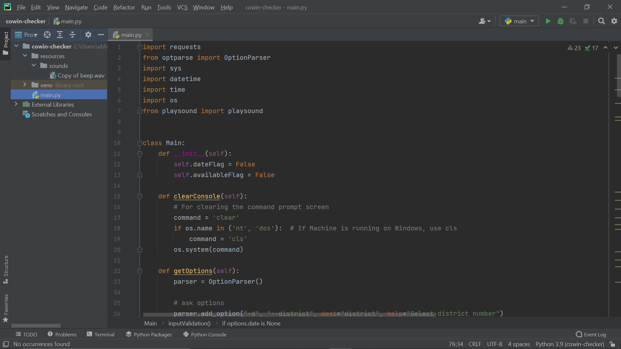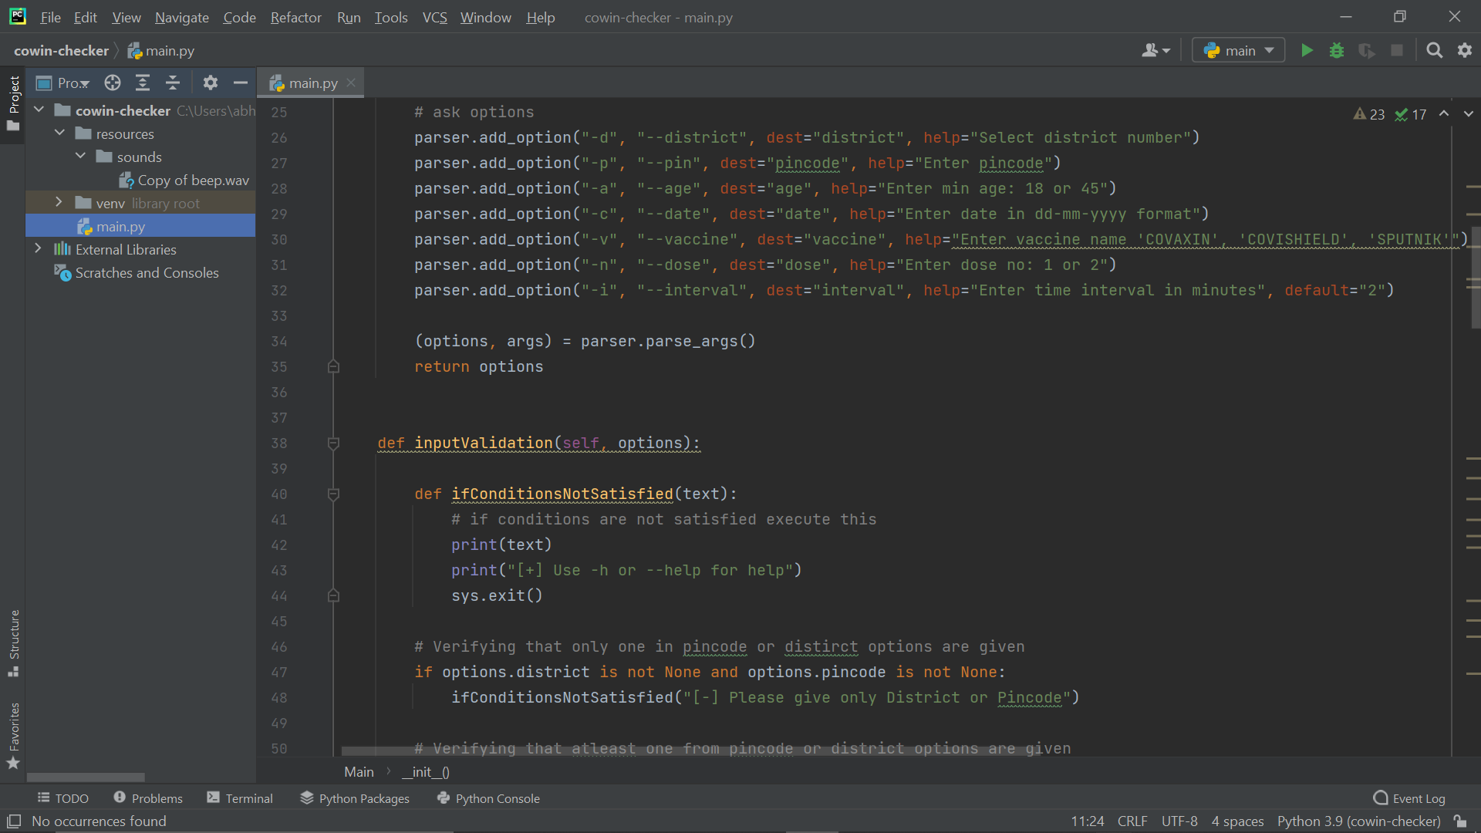

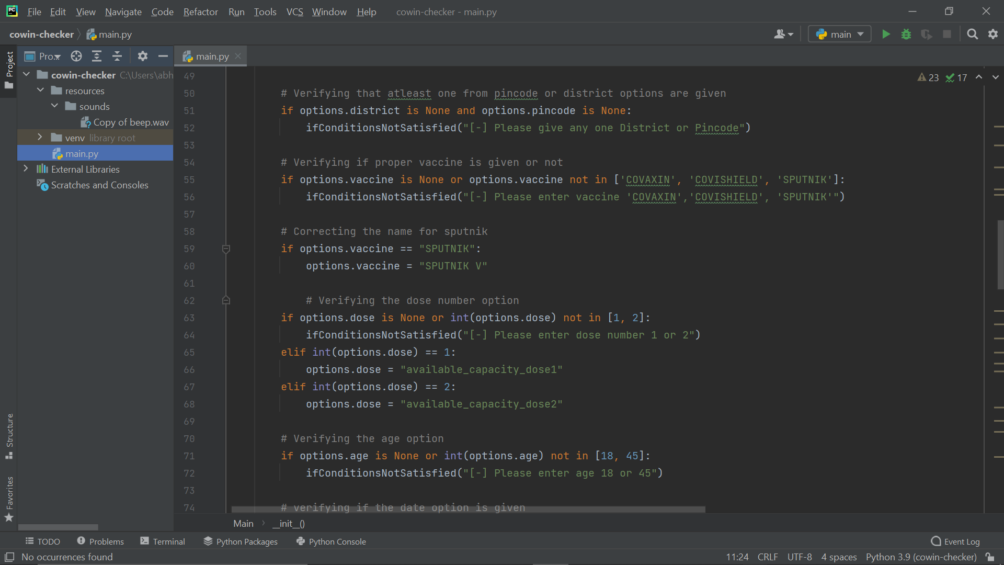

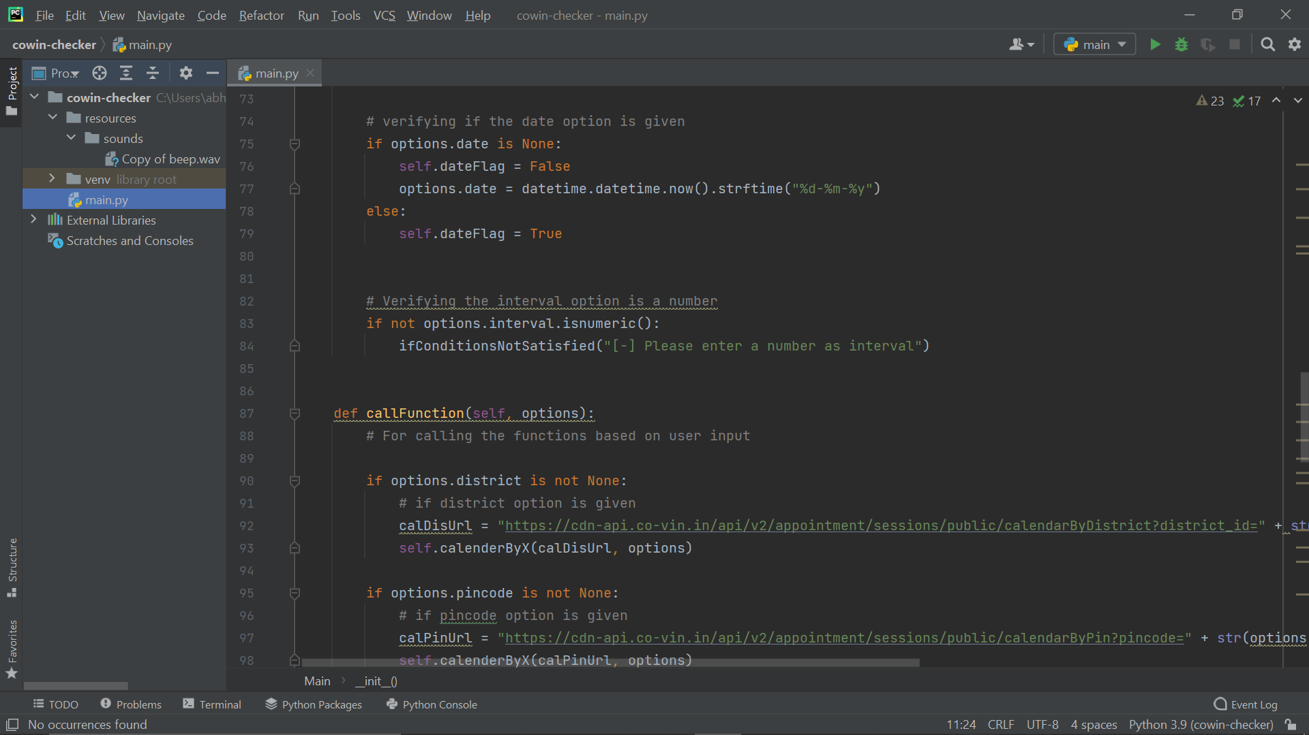

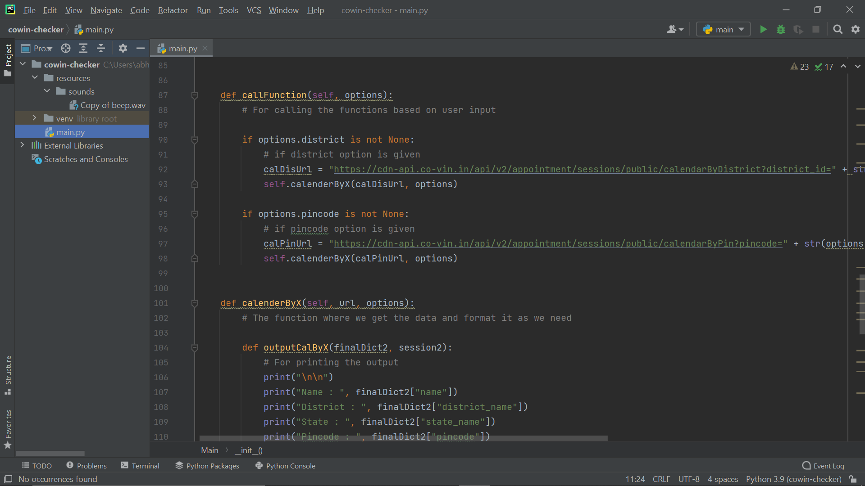

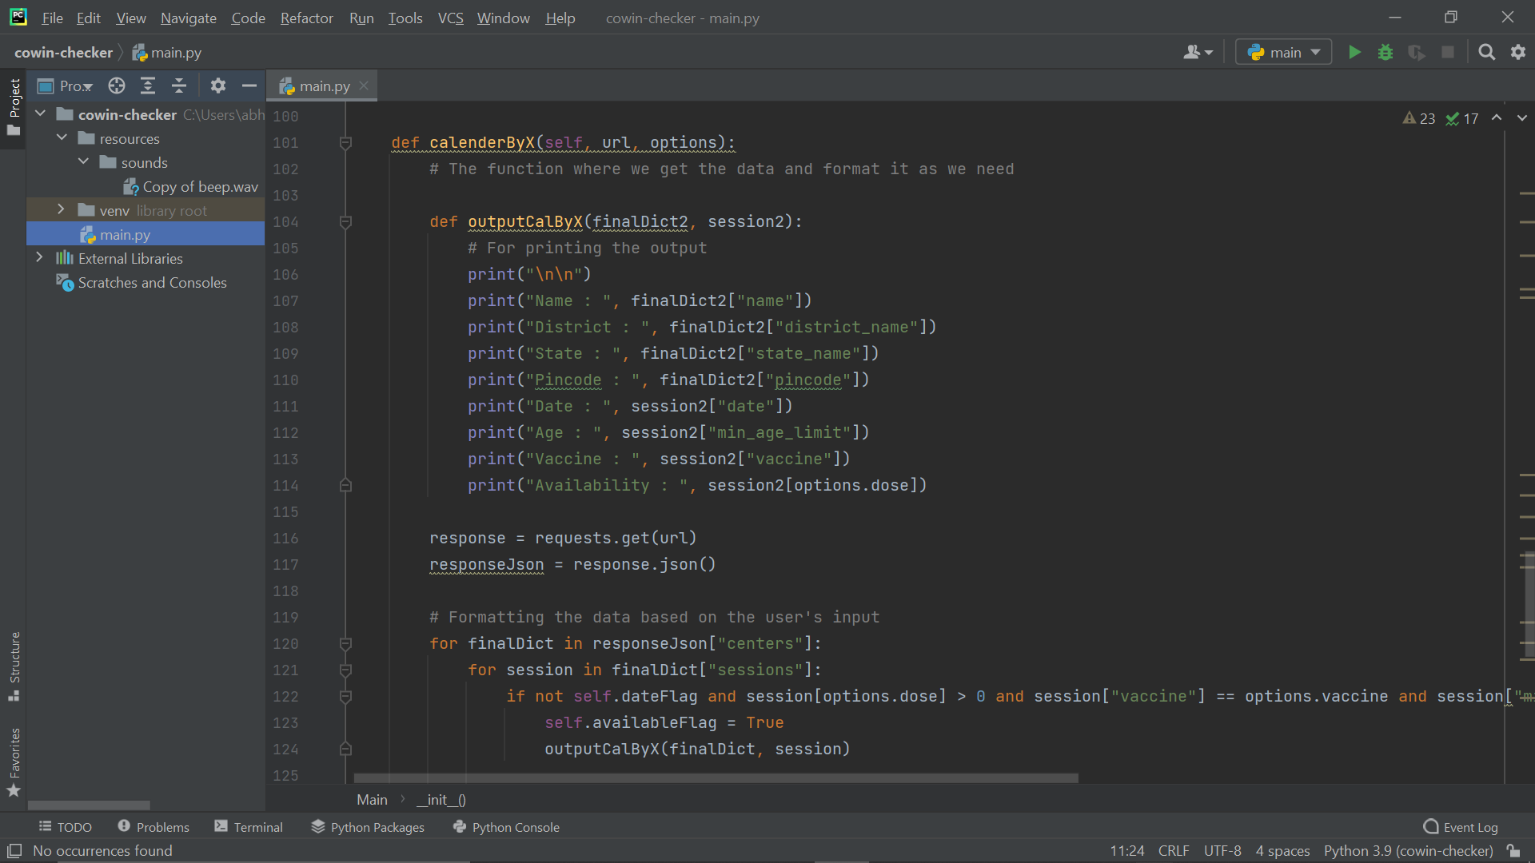

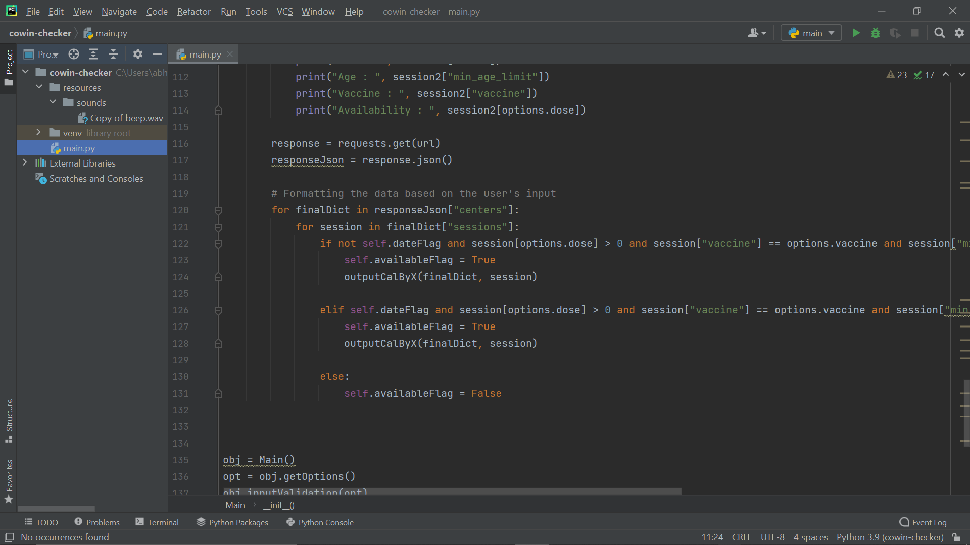

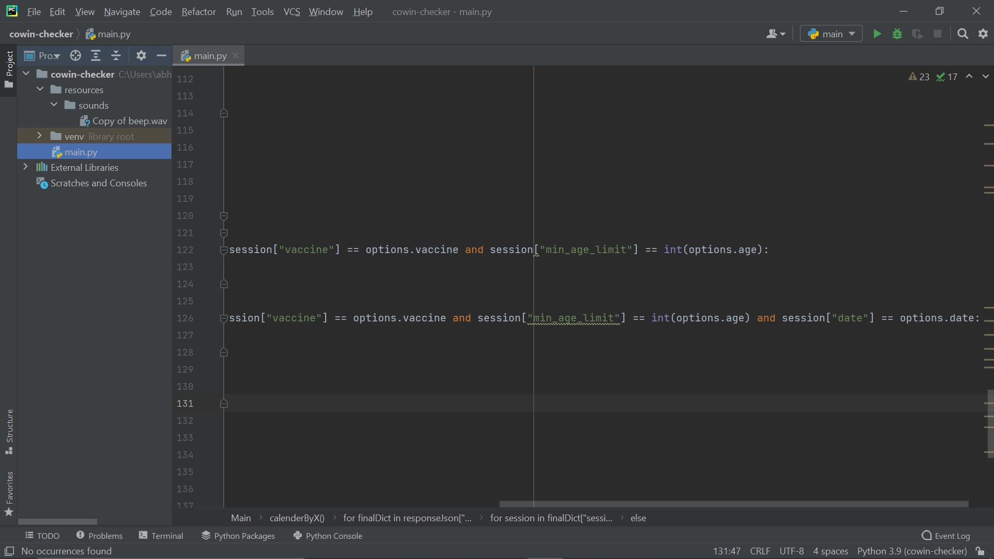

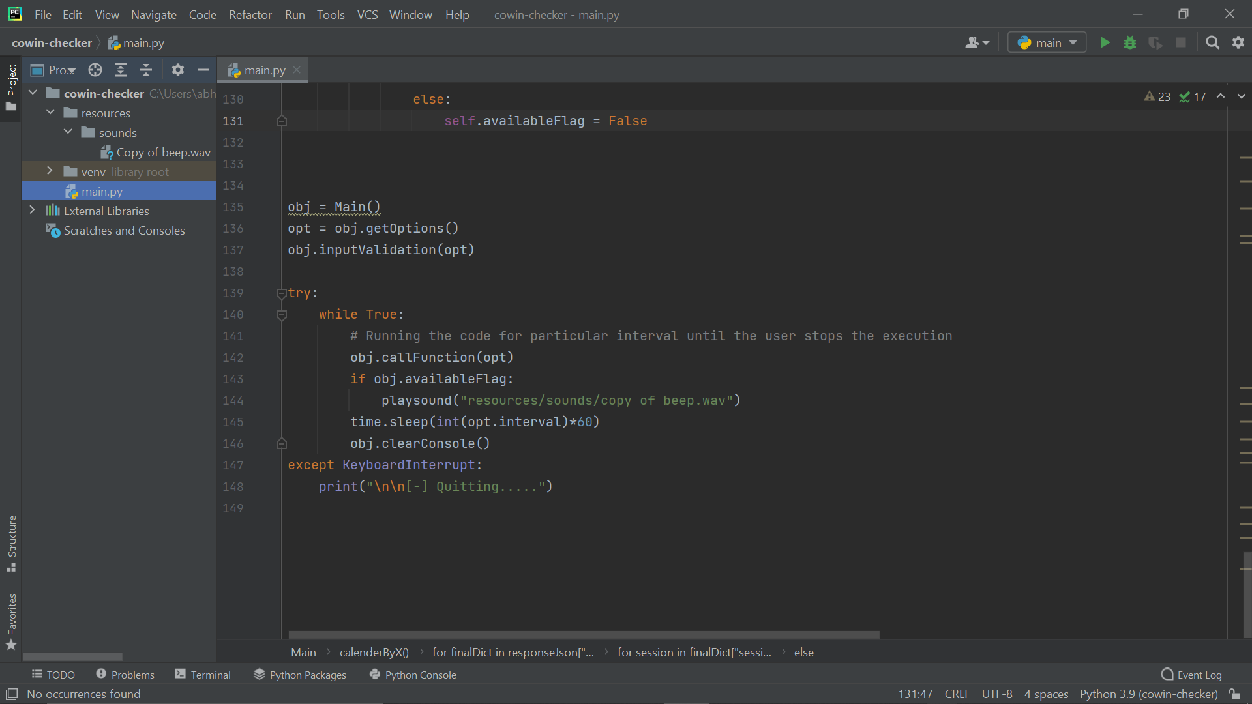

OUTPUT -1

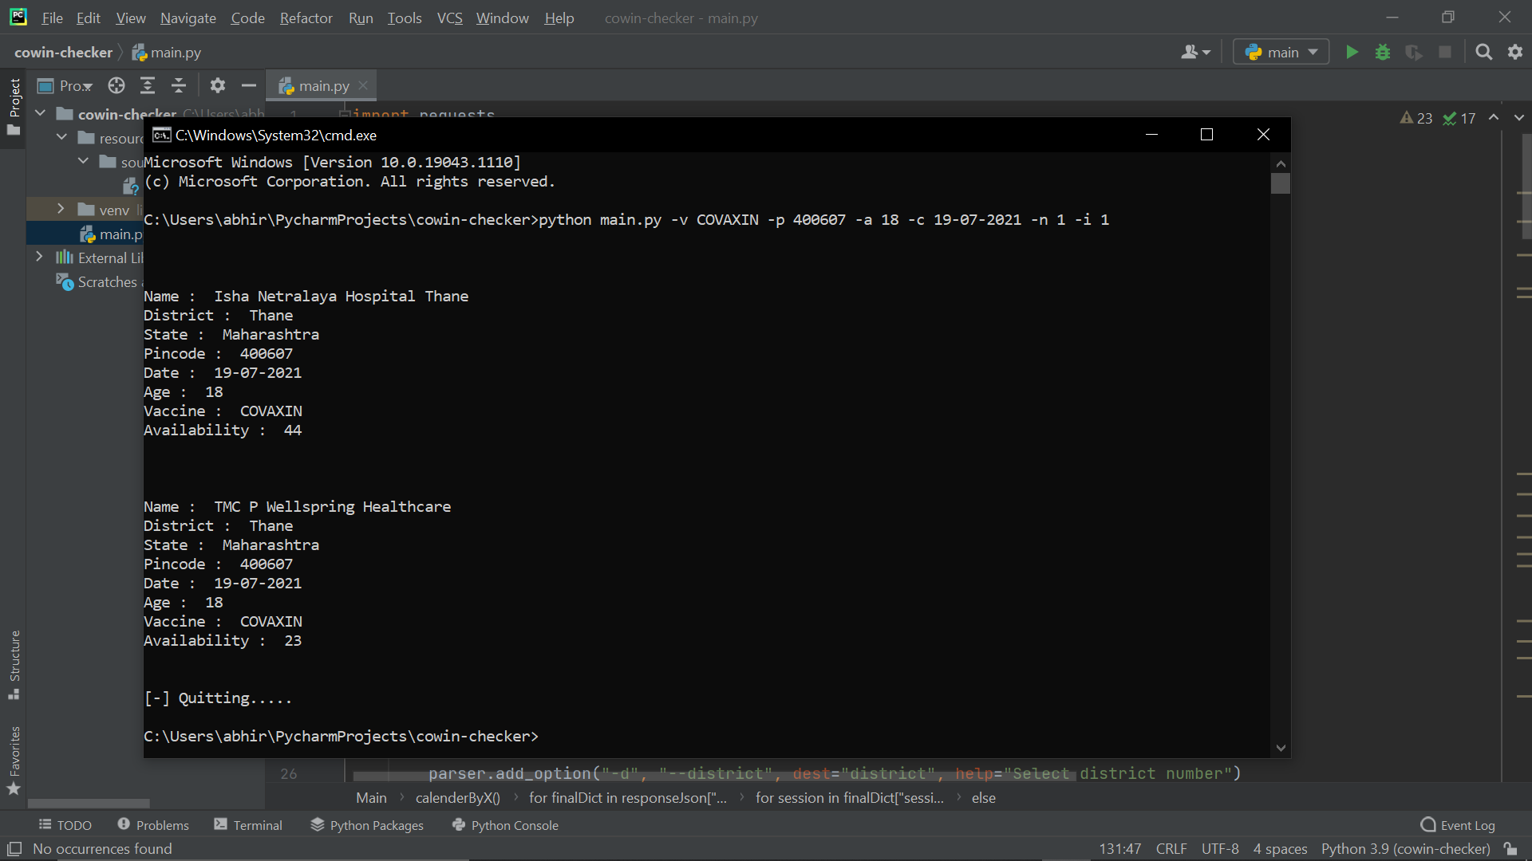

OUTPUT-2

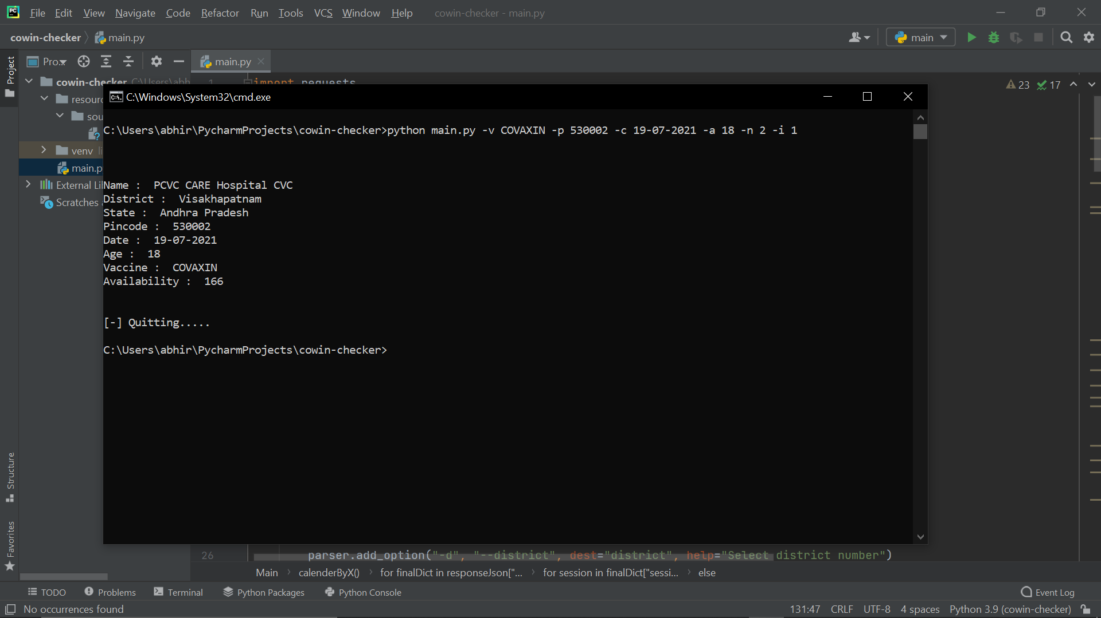

OUTPUT-3

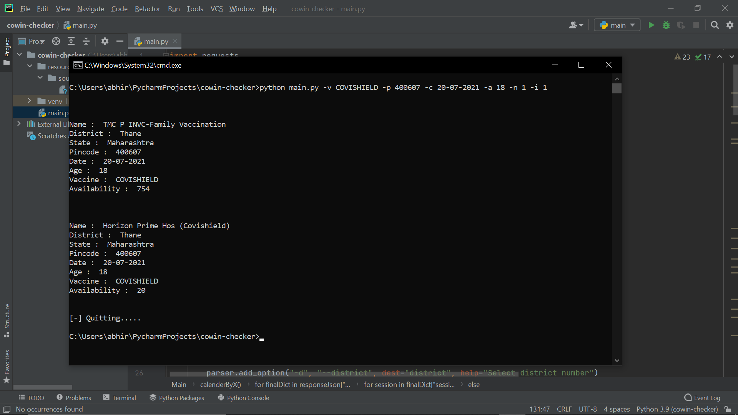

OUTPUT-4

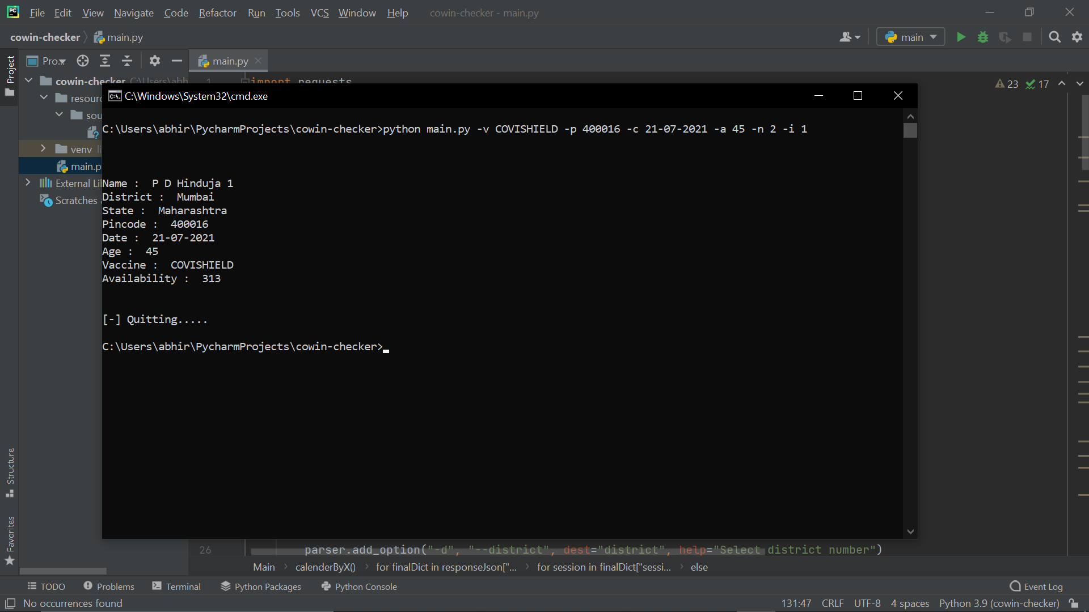

OUTPUT-5

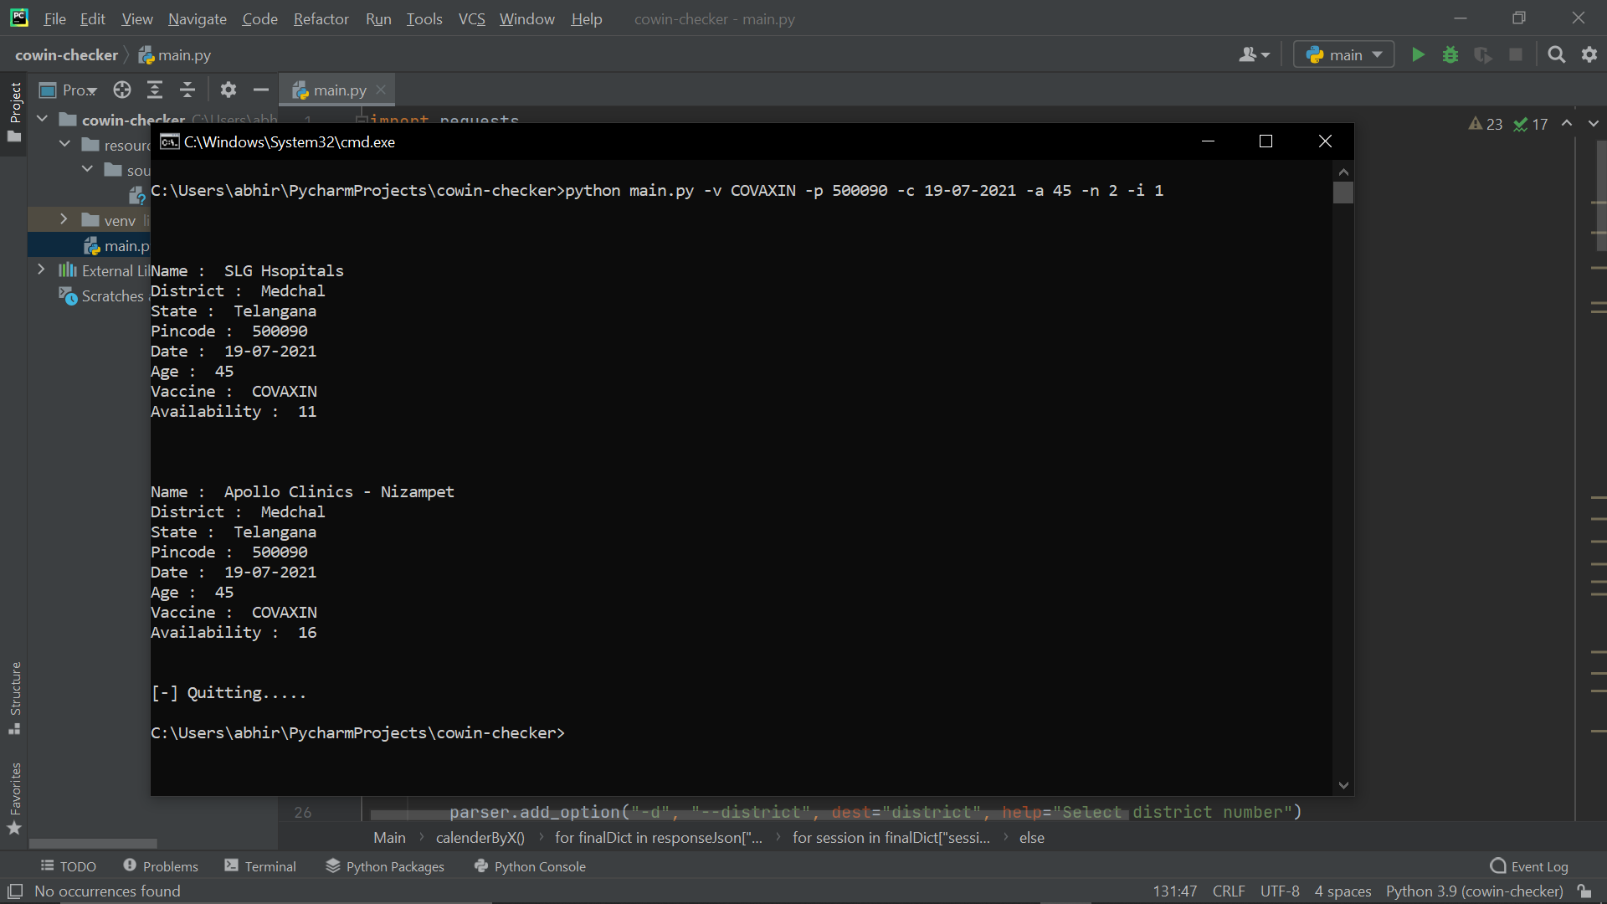

REFERENCES

1) https://www.cowin.gov.in/

2) <https://apisetu.gov.in/public/marketplace/api/cowin#/>

3) <https://www.geeksforgeeks.org/>

4) https://www.w3schools.com/